|  |
| --- |
| REPORT  COMPUTATIONAL INTELLIGENCE  ASHITA DIWAN (6)  SURBHI MITTAL (43)  VINEETA GOSWAMI (48) |

**PROBLEM**

Given a dataset ("train_cancer.h5") containing:

* a training set of 380 records containing diagnostic cancer information labeled as benign (y=1) or malignant(y=0)
* a test set of 189 records labeled as benign or malignant

The problem is to build a simple text recognition algorithm that can correctly classify records as benign or malignant.

**DATASET**

Breast Cancer Dataset

Files used : cancer_train.h5, cancer_test.h5

Total instances : 569

Training instances: 380

Testing instances : 189

**About train_set_x and test_set_x:**

Ten real-valued features are computed for each cell nucleus:

a) radius (mean of distances from center to points on the perimeter)

b) texture (standard deviation of gray-scale values)

c) perimeter

d) area

e) smoothness (local variation in radius lengths)

f) compactness (perimeter^2 / area - 1.0)

g) concavity (severity of concave portions of the contour)

h) concave points (number of concave portions of the contour)

i) symmetry

j) fractal dimension ("coastline approximation" - 1)

The mean, standard error, and "worst" or largest (mean of the three

largest values) of these features were computed for each image,

resulting in 30 features. For instance, field 1 is Mean Radius, field

11 is Radius SE, field 21 is Worst Radius.

All feature values are recoded with four significant digits.

**About train_set_y and test_set_y:**

Classes used:

1. Malignant: 0
2. Benign : 1

**ALGORITHM**

Build a Logistic Regression, using a Neural Network mindset.

Steps for building a Neural Network are:

1. Define the model structure (such as number of input features)

2. Initialize the model's parameters

3. Loop:

- Calculate current loss (forward propagation)

- Calculate current gradient (backward propagation)

- Update parameters (gradient descent)

**LOGISTIC REGRESSION**

To train the parameters 𝑤 and 𝑏, we need to define a cost function.

𝑦̂(𝑖) = 𝜎(𝑤𝑇𝑥(𝑖) + 𝑏), where 𝜎(𝑧(𝑖))= 1 1+ 𝑒−𝑧(𝑖)

𝐺𝑖𝑣𝑒𝑛 {((1), 𝑦(1) ), ⋯ , (𝑥(𝑚), 𝑦(𝑚) )}, 𝑤𝑒 𝑤𝑎𝑛𝑡 𝑦̂(𝑖) ≈ 𝑦(𝑖)

Loss (error) function:

The loss function measures the discrepancy between the prediction (𝑦̂(𝑖)) and the desired output (𝑦(𝑖)). In other words, the loss function computes the error for a single training example.

(𝑦̂(𝑖), 𝑦(𝑖)) = 12 (𝑦̂(𝑖) − 𝑦(𝑖))2

𝐿(𝑦̂(𝑖), 𝑦(𝑖)) = −( 𝑦(𝑖) log(𝑦̂(𝑖)) + (1 − 𝑦(𝑖))log (1 − 𝑦̂(𝑖))

• If 𝑦(𝑖) = 1: 𝐿(𝑦̂(𝑖), 𝑦(𝑖)) = − log(𝑦̂(𝑖)) where log(𝑦̂(𝑖)) and 𝑦̂(𝑖) should be close to 1

• If 𝑦(𝑖) = 0: 𝐿(𝑦̂(𝑖), 𝑦(𝑖)) = − log(1 − 𝑦̂(𝑖)) where log(1 − 𝑦̂(𝑖)) and 𝑦̂(𝑖) should be close to 0

Cost function:

The cost function is the average of the loss function of the entire training set. We are going to find the parameters 𝑤 𝑎𝑛𝑑 𝑏 that minimize the overall cost function. 𝐽(𝑤, 𝑏) = 1 𝑚 Σ 𝐿(𝑦̂(𝑖), 𝑦(𝑖)) 𝑚 𝑖=1 = − 1 𝑚 Σ[( 𝑦(𝑖) log(𝑦̂(𝑖)) + (1 − 𝑦(𝑖))log (1 − 𝑦̂(𝑖))]

**OPERATING ENVIRONMENT**

Operating System : Windows 10

Machine Architecture: 64-bit

Language : Python 2.7

Packages : numpy, scipy, matplotlib, h5py, PIL

**CODE**

import numpy as np

import matplotlib.pyplot as plt

import h5py

import scipy

from PIL import Image

from scipy import ndimage

from lr_utils import load_dataset

train_set_x_orig, train_set_y, test_set_x_orig, test_set_y, classes = load_dataset()

m_train = train_set_x_orig.shape[0]

m_test = test_set_x_orig.shape[0]

num_px = train_set_x_orig.shape[1]

print ("Number of training examples: m_train = " + str(m_train))

print ("Number of testing examples: m_test = " + str(m_test))

print ("train_set_x shape: " + str(train_set_x_orig.shape))

print ("train_set_y shape: " + str(train_set_y.shape))

print ("test_set_x shape: " + str(test_set_x_orig.shape))

print ("test_set_y shape: " + str(test_set_y.shape))

print ("classes: " + str(classes))

print ('\n' + "-------------------------------------------------------" + '\n')

max_val_train = np.max(train_set_x_orig,axis =0) # (1,30)

max_val_test = np.max(test_set_x_orig,axis =0) # (1,30)

train_set_x_norm = train_set_x_orig/max_val_train

test_set_x_norm = test_set_x_orig/max_val_test

train_set_x = train_set_x_norm.T

test_set_x = test_set_x_norm.T

print(train_set_x)

def sigmoid(z):

s = 1.0/(1.0+np.exp(-z))

return s

def propagate(w, b, X, Y):

m = X.shape[1]

A = sigmoid(np.dot(w.T, X) + b)

cost = (-1.0/m)*np.sum((Y*np.log(A)+ (1-Y)*np.log(1-A)), axis = 1)

dw = (1.0/m)*np.dot(X, (A-Y).T)

db = (1.0/m)*np.sum(A-Y, axis = 1)

assert(dw.shape == w.shape)

assert(db.dtype == float)

cost = np.squeeze(cost)

assert(cost.shape == ())

grads = {"dw": dw, "db": db}

return grads, cost

def optimize(w, b, X, Y, num_iterations, learning_rate, print_cost = False):

costs = []

for i in range(num_iterations):

grads, cost = propagate(w, b, X, Y)

dw = grads["dw"]

db = grads["db"]

w = w - learning_rate*dw

b = b - learning_rate*db

if i % 100 == 0:

costs.append(cost)

if print_cost and i % 100 == 0:

print ("Cost after iteration %i: %f" %(i, cost))

params = {"w": w,

"b": b}

grads = {"dw": dw,

"db": db}

return params, grads, costs

def predict(w, b, X):

m = X.shape[1]

Y_prediction = np.zeros((1,m))

w = w.reshape(X.shape[0], 1)

A = sigmoid(np.dot(w.T, X) + b)

p = np.zeros(m).reshape(1,m)

for i in range(A.shape[1]):

if A[0,i]>0.5:

Y_prediction[0,i] = 1

assert(Y_prediction.shape == (1, m))

return Y_prediction

def model(X_train, Y_train, X_test, Y_test, num_iterations = 2000, learning_rate = 0.5, print_cost = False):

w, b = np.zeros(X_train.shape[0]).reshape(X_train.shape[0],1), 0.0

parameters, grads, costs = optimize(w, b, X_train, Y_train, num_iterations, learning_rate, print_cost)

w = parameters["w"]

b = parameters["b"]

Y_prediction_test = predict(w, b, X_test)

Y_prediction_train = predict(w, b, X_train)

print("train accuracy: {} %".format(100 - np.mean(np.abs(Y_prediction_train - Y_train)) * 100))

print("test accuracy: {} %".format(100 - np.mean(np.abs(Y_prediction_test - Y_test)) * 100))

d = {"costs": costs,

"Y_prediction_test": Y_prediction_test,

"Y_prediction_train" : Y_prediction_train,

"w" : w,

"b" : b,

"learning_rate" : learning_rate,

"num_iterations": num_iterations}

return d

#end of functions

d = model(train_set_x, train_set_y, test_set_x, test_set_y, num_iterations = 2000, learning_rate = 0.005, print_cost = True)

print('\n' + "-------------------------------------------------------" + '\n')

costs = np.squeeze(d['costs'])

plt.plot(costs)

plt.ylabel('cost')

plt.xlabel('iterations (per hundreds)')

plt.title("Learning rate =" + str(d["learning_rate"]))

plt.show()

learning_rates = [0.01, 0.001, 0.0001]

models = {}

for i in learning_rates:

print ("learning rate is: " + str(i))

models[str(i)] = model(train_set_x, train_set_y, test_set_x, test_set_y, num_iterations = 1500, learning_rate = i, print_cost = True)

print ('\n' + "-------------------------------------------------------" + '\n')

for i in learning_rates:

plt.plot(np.squeeze(models[str(i)]["costs"]), label= str(models[str(i)]["learning_rate"]))

plt.ylabel('cost')

plt.xlabel('iterations')

legend = plt.legend(loc='upper center', shadow=True)

frame = legend.get_frame()

frame.set_facecolor('0.90')

plt.show()

**OUTPUT**

Number of training examples: m_train = 380

Number of testing examples: m_test = 189

train_set_x shape: (380, 30)

train_set_y shape: (1, 380)

test_set_x shape: (189, 30)

test_set_y shape: (1, 189)

classes: [b'maligna' b'benign']

-------------------------------------------------------

[[ 0.63998574 0.73176801 0.70046246 ..., 0.47883314 0.48594806

0.39416575]

[ 0.26425663 0.45239311 0.54098779 ..., 0.7181772 0.38569248

0.47937882]

[ 0.65145892 0.70503974 0.68965518 ..., 0.45564985 0.46827585

0.38885942]

...,

[ 0.91202742 0.63917524 0.83505154 ..., 0.19865979 0.36219931

0.86735398]

[ 0.69313043 0.41428143 0.54429042 ..., 0.40584514 0.51024407

0.62579089]

[ 0.57301205 0.42901206 0.42207232 ..., 0.34028918 0.46448195

0.6761446 ]]

Cost after iteration 0: 0.693147

Cost after iteration 100: 0.679428

Cost after iteration 200: 0.666393

Cost after iteration 300: 0.653930

Cost after iteration 400: 0.641993

Cost after iteration 500: 0.630552

Cost after iteration 600: 0.619583

Cost after iteration 700: 0.609061

Cost after iteration 800: 0.598965

Cost after iteration 900: 0.589274

Cost after iteration 1000: 0.579968

Cost after iteration 1100: 0.571027

Cost after iteration 1200: 0.562433

Cost after iteration 1300: 0.554169

Cost after iteration 1400: 0.546218

Cost after iteration 1500: 0.538564

Cost after iteration 1600: 0.531193

Cost after iteration 1700: 0.524091

Cost after iteration 1800: 0.517244

Cost after iteration 1900: 0.510640

train accuracy: 92.10526315789474 %

test accuracy: 94.17989417989418 %

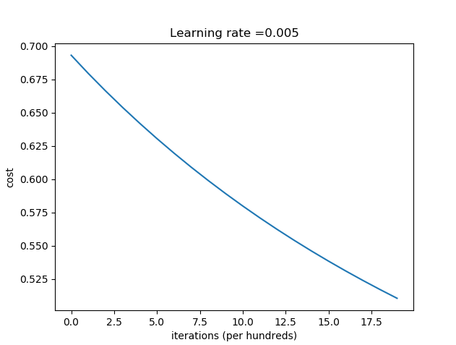

-------------------------------------------------------

learning rate is: 0.01

Cost after iteration 0: 0.693147

Cost after iteration 100: 0.666390

Cost after iteration 200: 0.641988

Cost after iteration 300: 0.619576

Cost after iteration 400: 0.598957

Cost after iteration 500: 0.579958

Cost after iteration 600: 0.562423

Cost after iteration 700: 0.546207

Cost after iteration 800: 0.531182

Cost after iteration 900: 0.517232

Cost after iteration 1000: 0.504255

Cost after iteration 1100: 0.492158

Cost after iteration 1200: 0.480859

Cost after iteration 1300: 0.470285

Cost after iteration 1400: 0.460370

train accuracy: 92.10526315789474 %

test accuracy: 95.76719576719577 %

-------------------------------------------------------

learning rate is: 0.001

Cost after iteration 0: 0.693147

Cost after iteration 100: 0.690338

Cost after iteration 200: 0.687564

Cost after iteration 300: 0.684823

Cost after iteration 400: 0.682112

Cost after iteration 500: 0.679429

Cost after iteration 600: 0.676773

Cost after iteration 700: 0.674142

Cost after iteration 800: 0.671536

Cost after iteration 900: 0.668954

Cost after iteration 1000: 0.666395

Cost after iteration 1100: 0.663859

Cost after iteration 1200: 0.661345

Cost after iteration 1300: 0.658853

Cost after iteration 1400: 0.656383

train accuracy: 92.10526315789474 %

test accuracy: 88.35978835978835 %

-------------------------------------------------------

learning rate is: 0.0001

Cost after iteration 0: 0.693147

Cost after iteration 100: 0.692865

Cost after iteration 200: 0.692582

Cost after iteration 300: 0.692300

Cost after iteration 400: 0.692019

Cost after iteration 500: 0.691738

Cost after iteration 600: 0.691457

Cost after iteration 700: 0.691177

Cost after iteration 800: 0.690897

Cost after iteration 900: 0.690617

Cost after iteration 1000: 0.690338

Cost after iteration 1100: 0.690059

Cost after iteration 1200: 0.689781

Cost after iteration 1300: 0.689502

Cost after iteration 1400: 0.689225

train accuracy: 84.21052631578948 %

test accuracy: 73.01587301587301 %

-------------------------------------------------------

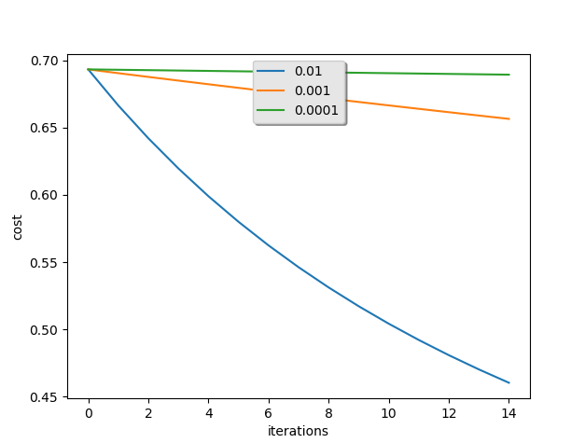

**BIBLIOGRAPHY**

1. Coursera – Deep Leaning AI by Andrew NG
2. UCI – Machine Learning Repository
3. www.google.com